Java Programming Exercise

Objective
Assess java programming, OOP, navigation in foreign code, documentation reading and following tasks skills.

How to do the exercise
The coding is done before the technical interview and sent to Fujitsu. At the interview you will be asked to walkthrough and discuss your solution.

First four tasks are mandatory, others not, but it is good to finish them also. We will verify result with own automated and unit tests and compare candidates based on test results and code quality.

Story
Few weeks left until Video rental store application delivery to customer, but our main developer left week ago and only you can help us to finish this application.

Currently we have clickable UI, file data store mocking which should be replaced with JSON and YAML file data store. All calculations and data verifications should be implemented, also some parts are done as rude prototype, need to apply your OOP skills to make code looks better.

Deadline one week starting from received project files. Follow tasks and we will make successful delivery.

Study code, read README.md file and Javadoc for getting technical information.

You are free to making global changes under the hood (adding new dependencies, refactoring), if you will comfortable with it, but please do not change UI or file data store interfaces, because we will use automated testing for test result verification.

Concurrency is not needed, let’s assume that it’s currently for only one opened browser window.

Tasks
Most of tasks in this document mirrored in code with TODO strings.

- Implement file data store with CREATE/EDIT/REMOVE possibilities. All changes happened in data should be stored to selected database file. Database path should be defined on the first screen of application. Database should work with two formats: YAML and JSON. Database file examples stored under db-examples folder. Follow test.fujitsu.videostore.backend.database. DBTableRepository Interface. Remove all test mocked data and use data from example database files. Database selection UI class - test.fujitsu.videostore.ui.database. DatabaseSelectionView. Implement data store file verification and error reporting! Cover this part with unit tests. Check first chapter under “Video rental store descriptions” for more details.

- Important! Replace “Your name here” label on about page with your name.

- Inventory, Customer list and Orders list views have a lot of common thing in code. There is many code duplicates. Generalize code using different OOP strategies. Check second chapter of “Video rental store descriptions”.

- Receipt calculations. For calculation rules, see third and fourth chapters under “Video rental store descriptions”. Replace dummy data to real calculations for creating receipts.
See test.fujitsu.videostore.ui.order package for all order and receipt related UI components. OrderToReceiptService for creating printable receipts.
Apply changes to database (update movies, customers bonus points, create new order, etc.) when order is approved or movies are returned. Cover this part with unit tests.

- Filtering in CRUD UI should work for Inventory, customer list and order list views. Classes to check: VideoStoreInventory, OrderList, CustomerList.
Filtering should be done automatically without clicking any button.
In code TODO’s is written by which parameters filtering should be done.

- Object removal system should be implemented acording fifth chapter of “Video rental store descriptions”.

- OrderedVideos class, Combobox with movie-to-order ID should list only available movies, means in stock more than zero.

- OrderedVideos class, Combobox with number-of-days ID. Number of movies should be validated; it should be more than zero.

- OrderForm class. User bonus points validation. Need to validate, that user have enough bonus points for making order.

- All other business logic stuff that you can imagine like: Disable delete button for Movie if it is rented, validation on negative numbers, recovering movies in stock after movie was returned, disable movie deletion if it’s rented.

- Rent (PrintableOrderReceipt) and Return (PrintableReturnReceipt) receipts data format. All dates should be in 15.05.2018 format. “day” or “days” should be displayed in correct form.

- Form Validations. Need to validate all forms. MovieForm, CustomerForm, OrderForm should be validated.

- MovieForm, CustomerForm, OrderForm forms delete button should be disabled during new item creation.

- Complete TODO’s in code, which is not mentioned in this task list and fix issues that you mentioned by yourself.

Video rental store descriptions

Database selection
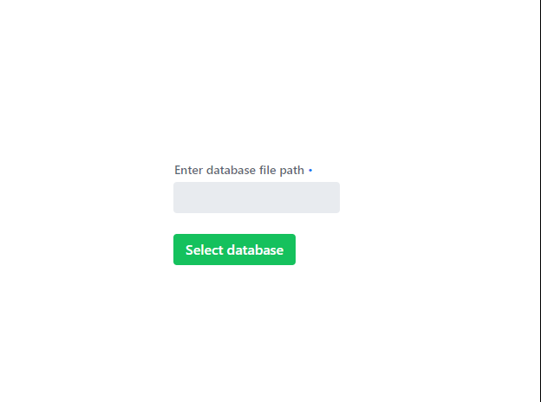
Simple view with one text field, where database path should can be entered. By clicking select database button database validated and if it is not valid then show error.
There can be two formats YAML and JSON. Examples of them stored under db-examples folder. For testing your implementation, please use these examples.

CRUD UI
Inventory, Customer and Orders views have table with data representation, filtering possibility, editing, deleting and creating new items.
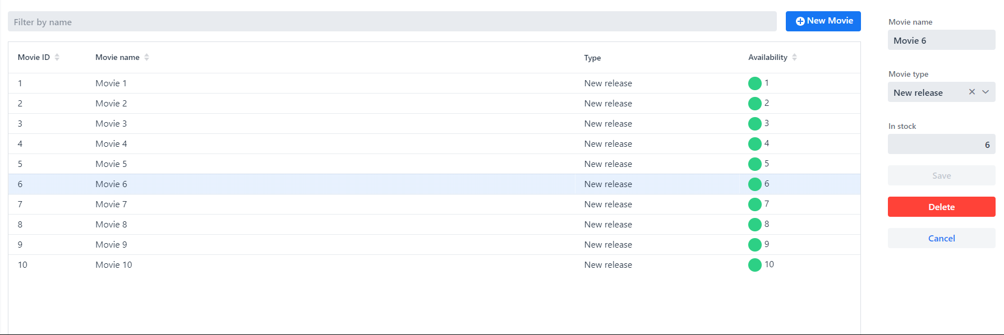

Filtering should be done automatically without clicking any button.
By clicking on row in table on the right side editing form is opened.
By clicking New button next to filtering opens new empty form for adding new item.
Deleting item should be not just deleting row from database, but sometimes it should lead to recovering dependency items. Sometimes deleting should be not available, if some resources is in use.

Price calculation
The price of rentals is based type of film rented and how many days the film is rented for. The customers say when renting for how many days they want to rent for and pay up front. If the film is returned late, then rent for the extra days is charged when returning.

The store has three types of films.
- New releases – Price is PREMIUM_PRICE times number of days rented.
- Regular films – Price is BASIC_PRICE for the fist 3 days and then BASIC_PRICE times the number of days over 3
- Old film - Price is BASIC_PRICE for the fist 5 days and then BASIC_PRICE times the number of days over 5

PREMIUM_PRICE is 4 EUR
BASIC_PRICE is 3 EUR

Bonus points calculation and payment
Customers get bonus points when renting films. A new release gives 2 points and other films give one point per rental. (Regardless of the time rented)
The system keeps track of how many bonus points the customers have and then the customers can use their bonus points to pay for a “new release” rentals. 25 points pays the rental for one day.

Object removal functionality
Movie removal functionality. Delete movie button should be inactive if it’s new movie creation or it was rented at least one time.
Customer removal functionality. Customer deletion button should be inactive if it’s new customer creation or customer have active rent’s. If customer deleted, then all his already inactive rent’s should be deleted also.
Order removal functionality. Order removal button should be inactive during new order creation or if order there is not all movies returned.

